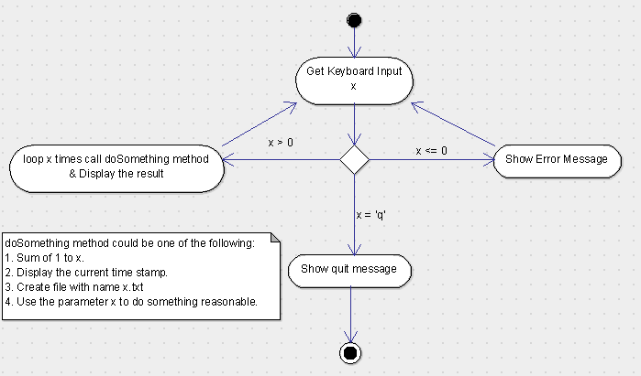
Assignment 1

- What is JDK? JRE? JVM?
JDK stands for Java development kit. It is a bundle of software development tools and supporting libraries combined with JRE(Java Runtime Enviornment) and JVM( Java Virtual Machine).
It is foundational component that enables Java application and Java applet development. It is platform-dependent.

JRE stands for Java Runtime Enviornment is a set of software tools responsible for execution of the Java program or application on your system.

JRE uses heap for dynamic memory allocation for Java Objects.JRE is also used for Java debugging.

JVM stands for Java Virtual Machine. It is a virtual machine that runs Java code as well as programs written in other languages that are also compiled to Java Bytecode.
JVM loads, verifies and executes Java bytecode.JVM is specifically convert byte code to machine code and it is platform-dependent. It performs many functions including memory management and security.
There are three sub system of JVM
- Class loader: is responsible for loading, linking and initializing a Java Class.
- Runtime Data Area: contains method area, PC registers, stack areas and thread.
- Execution Engine: contains an interpreter, compiler and garbage collection area.

- What is java compiler?
Java Compiler is a computer program that is used to compile Java programs. It converts source code(.java file) into byte code(.class). It is platform-independent.
Java compiler is responsible for
a) checks syntax error.
b)converts source into byte code with the help of JVM.

- Why is java platform independent?
Java is Platform-independent because Java compiled code(byte code) can be run on any operating system.

- What is IDE? Why is it important for developers?
IDE stands for integrated development Environment. It is a software for building applications that combines all developers tool into a single graphical user interface.
IDE is designed for developers so that they can save time and built application by
2)Syntax highlighting
b)Text autocompletion
c)Refactoring option
d)Importing libraries
e)build, compile or run

- Is java case sensitive?
Yes.
- What do the following key words do?
Static: A non-access modifier used for inner classes, methods and attributes. Static methods/attributes can be accessed without creating an object of a class.
Final: A non-access modifier used for classes, attributes and methods, which makes them non-changeable (impossible to inherit or override)
public,: An access modifier used for classes, attributes, methods and constructors, making them accessible by any other class.
Private: An access modifier used for attributes, methods and constructors, making them only accessible within the declared class.
Void: Specifies that the method should not have a return value.
null: It can be assigned to any variable of a reference type(that is, a non primitive type) to indicate the variable does not refer to any object or array.
package: An access modifier used for attributes, methods and constructors, making them accessible in the same package and subclasses.
Class: It is used to declare a new Java Class, which is collection of variables and methods. A class is a template.
New: It is used to create a new instance of the class.

- What is primitive type and reference type?
Primitive type is the basic type of data like byte, short, int, long, float, double, boolean, char.
Reference Type is no primitive type of data. A variable of class type is called reference type.
- Is parameter passed by value or reference?
Parameters can be passed by value. Object references are passed by value.

- What is the output: System.out.println(1 > 0 : “A”:”B”);
It gives a compile time error.

- How to define constants in java?
We can use them with final keyword.

- What is String? Is it primitive type?
String is a non primitive data type. Java platform provides string class to create and manipulate string.

- How to check if a String is representing a number?
By parsing it with available methods like Integer.parseInt(String)

- Write a program to implement the following activity diagram:

package javaAntra;

import java.util.Scanner;

public class DoSomething {

public static void main(String[] args) {
// TODO Auto-generated method stub

Scanner sc = new Scanner(System.in);
System.out.println("You can enter any number or q to quit:");
String input = null;
//Save the input number in String
input = sc.next();

//Convert the input to charate Array
char[] inputArray = input.toCharArray();
int i = 0 ;
try {
// If letter is q then type a bye message
if(inputArray.length <=1 && inputArray[0] == 'q') {
System.out.println("Good bye");
//Check if it is less than Zero
}else if(Integer.parseInt(input) <= 0) {
System.out.println("We need positive integer");

}else {
//Convert to integer
i = Integer.parseInt(input);
}
//Call a method to print date for n number of time
while (i > 0) {
currentTimeStamp();
i--;
}
// Catch Exception if it enters some other input
}catch(Exception e) {
System.out.println("There is not a valid input.");
}finally {
// Close the connection
sc.close();
}
}

private static void currentTimeStamp() {
// TODO Auto-generated method stub
java.util.Date date = new java.util.Date();
System.out.println(date.toString());

}

}

- Write a program to merge two array of int.
public class MergeArrayInt {

public static void mergeIntegerArray(int[] array1, int[] array2) {
// Create an array that has length of first array+ second array
int[] mergeArray = new int[array1.length + array2.length];
//for loop to add the elements of first array to final array
for(int i = 0; i < array1.length; i++) {
mergeArray[i] = array1[i];
}
//for loop to add the elements of second array to final array
for(int i = 0, j=array1.length; i <array2.length; i++) {
mergeArray[i+j] = array2[i];
}
//For printing the final array
for (int i : mergeArray) {
System.out.print("" + i + ",");
}
}

public static void main(String[] args) {
// TODO Auto-generated method stub
int[] array1 = {1,2,3,4,5};
int[] array2 = {6,7,8,9,10};
mergeIntegerArray(array1, array2);

}

}
- Write a program to find the second largest number inside an array of int.

import java.util.ArrayList;
import java.util.Collections;
import java.util.List;

public class SecondLargestNumber {

public static void main(String[] args) {

// TODO Auto-generated method stub
int[] number = {1,2,4,5,6,7,3};
//{1,3,52,3,6,3,5,8};

//For second largest number

List<Integer> array = new ArrayList<Integer>();

for(int i = 0; i < number.length; i++) {
array.add(number[i]);
}

Collections.sort(array);
System.out.println(array.get(array.size()-2));

}

}

